CMPE 480 INTRODUCTION TO ARTIFICIAL INTELLIGENCE
MIDTERM ANSWERS

- Is the problem decomposable?
M&C is not a decomposable problem. Each move depends on the other moves and they can not be considered separately.
Can solutions steps be ignored?
Solution steps can neither be ignored nor undone; it is an irrecoverable problem. After we make a move in the state space, we are in a new state and the move can not be ignored or recovered. We must continue from the current state.
Is the universe predictable?
Yes, the universe is completely predictable. So, planning a complete solution is possible beforehand and steps can be ignored during planning.
Is a good solution absolute or relative?
A good solution is absolute. It is sufficient to get everyone to the other side of the river by a sequence of moves in the state space. It is not necessary to find an optimal solution (e.g. the quickest way to accomplish the goal).
Is the solution a state or a path?
The solution is a path. It is not sufficient to give an answer like “everyone is on the other side of the river”. We must output all the moves from the initial state to the goal state.
What is the role of knowledge?
We need a small amount of knowledge for this problem. There is not even much additional knowledge that can be used to improve efficiency.
Does the task require interaction with a person?
No interaction is required. It is a solitary problem. The computer does not get advice during the solution and it is not necessary to tell the user how the computer is solving.

- States: A state consists of an ordered sequence of three numbers representing, respectively, the number of missionaries (0..3), the number of cannibals (0..3) and the number of boats (0 or 1) on the bank of the river from which they started.
Start state: (3,3,1)
Goal state: (0,0,0)
Operators: From each state, the possible operators are to take either one missionary, one cannibal, two missionaries, two cannibals, or one of each across in the boat. Thus, there are at most five operators, although most states have fewer.

An alternative representation:
States: A state consists of two ordered pairs. The first pair describes one side (the initial side) of the river and the second describes the other side. The first element of each pair is the number of missionaries (0..3) and the second element is the number of cannibals (0..3). The sum of the first elements or the second elements of the two pairs must be 0..3.
Start state: ((3,3), (0,0))
Goal state: ((0,0), (3,3))
Operators: The same as in the previous representation.

- Admissibility: A search algorithm (heuristic) is admissible if, for any graph, it always terminates in an optimal path from the initial node to a goal node whenever such a path exists.

Monotonicity: A heuristic function f′=g+h′ is monotone if
for all states n_{i} and n_{j}, where n_{j} is a descendant of n_{i},
h′(n_{i})-h′(n_{j})≤cost(n_{i},n_{j})
where cost(n_{i},n_{j}) is the actual cost of going from n_{i} to n_{j}.

Informedness: Suppose that we have two A* algorithms, A₁ and A₂ with the evaluation functions f₁′(n)=g₁(n)+h₁′(n) and f₂′(n)=g₂(n)+h₂′(n). We say that A₂ is more informed than A₁ if for all non-goal nodes n, h₂′(n)>h₁′(n).

Breadth-first search is admissible. Because, f′=g+h′, where g is the number of steps and h′=0. Since h′<h, h′ underestimates h. This means that the algorithm always finds the optimal solution.

For the 8-puzzle game, consider the following two heuristics: h₁′ is the number of tiles not in the goal position and h₂′ is the sum of the direct distances of tiles out of place. It is obvious that h₁′< h₂′ always. That is, an A* algorithm based on h₂′ will be more informed that an A* algorithm based on h₁′.

- a)
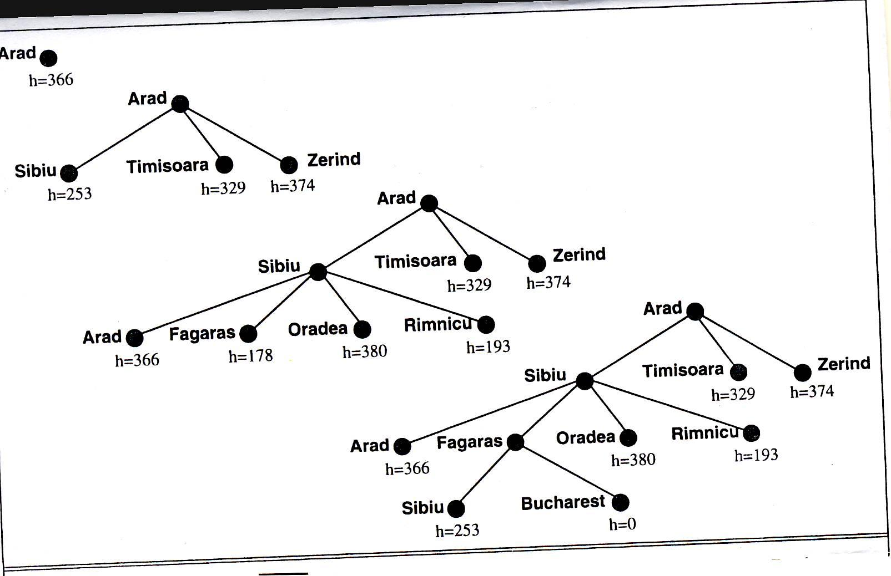

b)
