CMPE 480 INTRODUCTION TO ARTIFICIAL INTELLIGENCE 14.4.2015
MIDTERM

- As we know, we have seven problem characteristics (“Is the problem decomposable?”, “Can solutions steps be ignored?”, etc.) that are used to understand the types of problems. Consider the missionaries and cannibals (M&C) problem. Comment on this problem in terms of these problem characteristics. For each characteristic, indicate briefly what type of a problem M&C is and why.
Missionaries and cannibals problem: Three missionaries and three cannibals are on one side of a river, along with a boat that can hold one or two people. Find a way to get everyone to the other side of the river, without ever leaving a group of missionaries in one place outnumbered by the cannibals in that place (otherwise, the cannibals will eat the missionaries in that place).

- Define the M&C problem in terms of the state space formalism. That is, define what are the states, what is the start state, what is the goal state, and what are the possible operators.

- Give the formal definitions of the following properties of heuristics: admissibility, monotonicity, and informedness. Give an example of an admissible search algorithm and briefly explain why it is admissible. Give an example for informedness and explain briefly.

- Consider the following map. We want to search for a path from the city Arad (start node) to the city Bucharest (goal node). By using best-first search (i.e. f′=g+h′), show the search as a tree for the following two cases:
- g=0, h′=straight-line distance to Bucharest
- g=distance from start node to that node, h′=straight-line distance to Bucharest

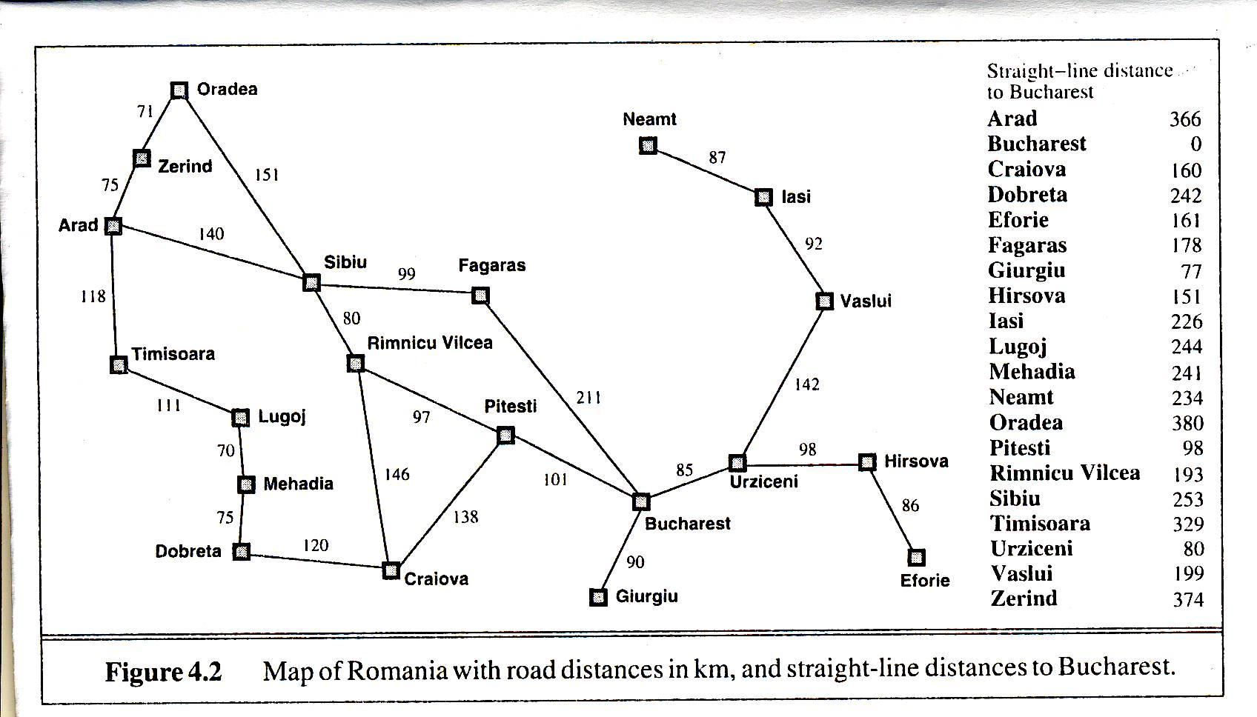

Notes:
- Questions 1-4 : 25 points
- Time: 1:20 hours
- Close notes/books

(continued on next page)

Seni, anlatabilmek seni,
İyi çocuklara, kahramanlara.
Seni, anlatabilmek seni,
Namussuza, haldan bilmez,
Kahpe yalana.

Ard-arda kaç zemheri,
Kurt uyur, kuş uyur, zindan uyurdu.
Dışarda gürül-gürül akan bir dünya...
Bir ben uyumadım,
Kaç leylım bahar,
Hasretinden prangalar eskittim.
Saçlarına kan gülleri takayım,
Bir o yana,
Bir bu yana...

Seni, bağırabilsem seni,
Dipsiz kuyulara,
Akan yıldıza,
Bir kibrit çöpüne varana,
Okyanusun en ıssız dalgasına
Düşmüş bir kibrit çöpüne.

Yitirmiş tılsımını ilk sevmelerin,
Yitirmiş öpücükleri,
Payı yok, apansız inen akşamdan,
Bir kadeh, bir cıgara, dalıp gidene,
Seni, anlatabilsem seni...
Yokluğun, Cehennemin öbür adıdır
Üşüyorum, kapama gözlerini...

