**CMPE 480 INTRODUCTION TO ARTIFICIAL INTELLIGENCE** 17.11.2015

**MIDTERM**

1. What are the three basic types of problems that artificial intelligence deals with? (One of them is “formal tasks”; what are the other two?) Explain each problem type in detail and give examples for each. Explain the differences between these three problem types.
2. Consider the water jug problem: You are given two jugs, a 5-gallon jug and a 3-gallon jug. Both jugs are initially empty. Neither has any measuring markers on it. There is a pump that can be used to fill the jugs with water. How can you get exactly 2 gallons of water in the 5-gallon jug.

Solve this problem using best-first search method. Define the problem and the rules formally (you can define as many rules as necessary). Define a heuristic. Then show the execution of the algorithm on a tree/graph. It is not necessary to show the complete solution; just show a few steps clearly.

1. Consider the following maze, in which a robot is trying to go from the start location to the finish location. The possible operators are up, down, left, and right, which are only valid if there is a dashed line between the grid boxes in the map of the maze. Consider that the heuristic used is the straight-line distance between the current position in the maze and the exit from the maze. Show how the robot will move in the maze using
2. Steepest-ascent hill-climbing search (gradient search)
3. Best-first search.

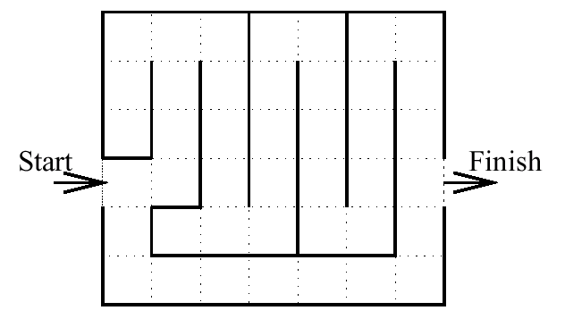

1. Suppose that you have an admissible heuristic h′. Is h′2 admissible? Is $√h'$ admissible? Is using any of these alternatives better or worse than using h′ in the A* algorithm?
2. For a problem, give an example admissible heuristic. You can think of any problem you like. Explain clearly why it is admissible.
3. Prove that any monotonic heuristic is also admissible. (Hint: Consider a path from a state s1 to a goal state sn. Use the monotonicity property between the states on this path.)

*Notes:*

* Questions 1-4 : 25 points
* Time: 1:45 hours
* Close notes/books

(continued on next page)

Kim bilir ne oldu ne bitti gece uyurken

Uyandım ki tabiat o değil başkasıdır

Nerden esiyor bu şerbet gibi hava nerden

Çiçek açmış ağaç hangi kızın rüyasıdır.

Güzelliğine imrendiğimiz dünyasında

Çocuğun saltanatını gör arabasında

Ne var ki şu geçen yosmanın kırıtmasında

Gencin ihtirası yaşlının hâtırasıdır.

Gel böyle havada kendini emniyette bil

Bir bakış bir gülüşle çarpılmak işten değil

Çektiğim ağrı kalpten bermutad dişten değil

Bildim bileli bahar başımın belâsıdı.