**CMPE 480 INTRODUCTION TO ARTIFICIAL INTELLIGENCE** 4.1.2016

**FINAL**

1. 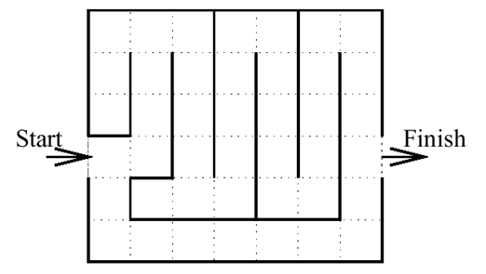*Application project*: Consider the maze in the figure, in which a robot is trying to go from the start location to the finish location. The possible operators are up, down, left, and right, which are only valid if there is a dashed line between the grid boxes in the map of the maze. We want to design a program that finds a possible path from the start location to the finish location. You may assume that the maze always has a single entry point and a single exit point. Write a Prolog program, as you did in the project, that uses best first search for solving this problem. Use two different heuristics.
2. *Research project*: Consider the artificial intelligence topic you chose in the project. Explain the topic, as you did in the project, in a reasonable amount of detail.
3. Document classification is the problem of determining the class (category) of a given document among a set of possible categories. For instance, given a document about the life of Beethoven, we can assign it to the “music” class (by using some data about the document) among the set of classes {music, sport, ...}. Design a very simple artificial neural network (ANN) that learns the class of a document.

First decide on the features you will use for learning, and then the structure of the ANN. Explain.

Then, using this system, show the learning process on a very simple example. For instance, you can use 3-4 very short documents (each containing 2-3 words) and 2-3 classes.

1. Explain the following knowledge representation issues. For each, also give examples.
2. What are the domain-independent, important attributes used in representations?
3. What is the inverse of an attribute?
4. What is attribute hierarchy?
5. What are single-valued and multi-valued attributes?
6. What do we mean by low-level and high-level primitives? What are the advantages and disadvantages?
7. Given a text, how can the corresponding script be found? Explain the problems and their solutions.

*Notes:*

* Questions 1,2:20 points; 3,4:30 points
* Time: 2:00 hours
* Close notes/books

(continued on next page)

Biz ki boş yere gerilmişiz anladık artık,

Yıldızların amansız çarkına

Ve boş yere sızlamış kemiklerimiz,

Bilmiyoruz şimdi, mevsim yaz mı, bahar mı

Bahçelerde hâlâ güller açar mı,

Bilmiyoruz, kadınlar, kızlar,

Şarkılar masallar var mı?

Gece ile gündüz,

Acıdan kaskatı kesilmiş yüz,

Uykusuzluktan harap göz,

Öpüşen dudaklar,

Çözülmeye razı olmayan eller var mı?

Ayrılık var mı gurbet var mı?

Biz beyhude yere gecikenler,

Çoktan bitmiş bir yolun ucunda

Bilmiyoruz şimdi ıssız gecede

Ne yapar ne eder,

Gidip de gelmeyenler,

Beyhude bekleyenler!

Biz ayın çıplak arsasında

Savrulan zaman kırıntıları,

Nerden bilelim bunları!